# Roll the Dice - Updated Solution

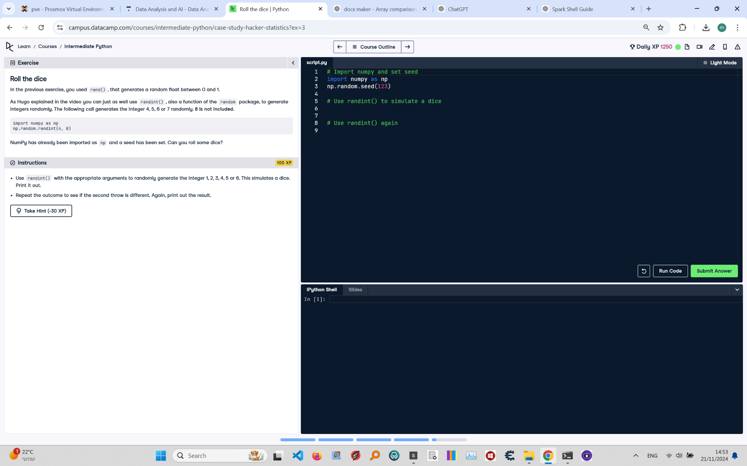

Below is the exercise on 'Roll the Dice' from the Python course. The image includes the instructions, code, and updated solution.

Updated Solution:

# Import numpy and set seed  
import numpy as np  
np.random.seed(123)  
  
# Use randint() to simulate a dice  
dice_throw1 = np.random.randint(1, 7) # Randomly generates a number between 1 and 6  
print(np.random.randint(1, 7)) # Prints another random integer between 1 and 6  
  
# Use randint() again  
dice_throw2 = np.random.randint(1, 7) # Randomly generates another number between 1 and 6  
print(np.random.randint(1, 7)) # Prints another random integer between 1 and 6

Explanation:

1. Import numpy as np and set the random seed using np.random.seed(123) to ensure reproducibility.

2. The first dice throw is simulated using np.random.randint(1, 7), generating a random integer between 1 and 6. This is stored in dice_throw1.

3. np.random.randint(1, 7) is called again to generate and print another random integer between 1 and 6.

4. The second dice throw is simulated using np.random.randint(1, 7), and stored in dice_throw2. Another random integer is printed as the second result.